Time lapse Video

#### With Raspberry Pi and Windows Azure

# Objectives

* Produce time-lapse video, upload it onto cloud and store it as a movie file.

## Stretch Goals

* send notifications of the upload to subscribers
* back-up the movie file after certain period.

# Ingredients

1. Raspberry Pi
2. Windows Azure Subscription
3. Raspberry Pi digital camera
4. Patience … lots off.

# Recipe

You’ll need a device which can capture the photo. For this project, I’ve chosen a Raspberry Pi (2) device with which a camera is attached. Few snaps of the device, camera module and connection are shown below.

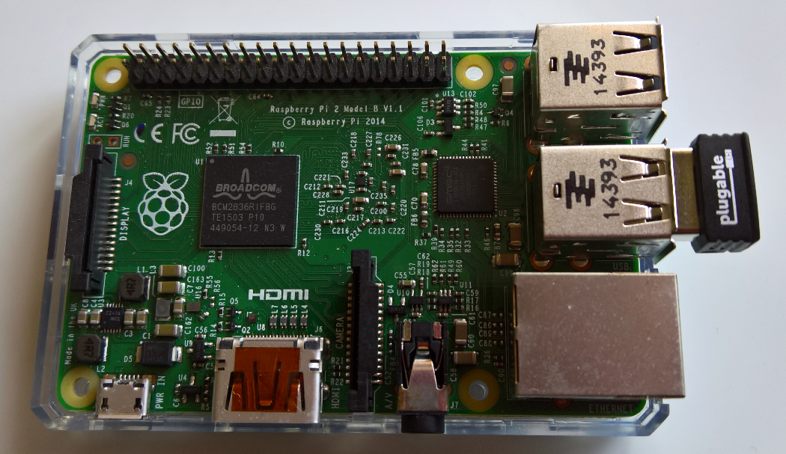

Figure 1: Raspberry Pi Device

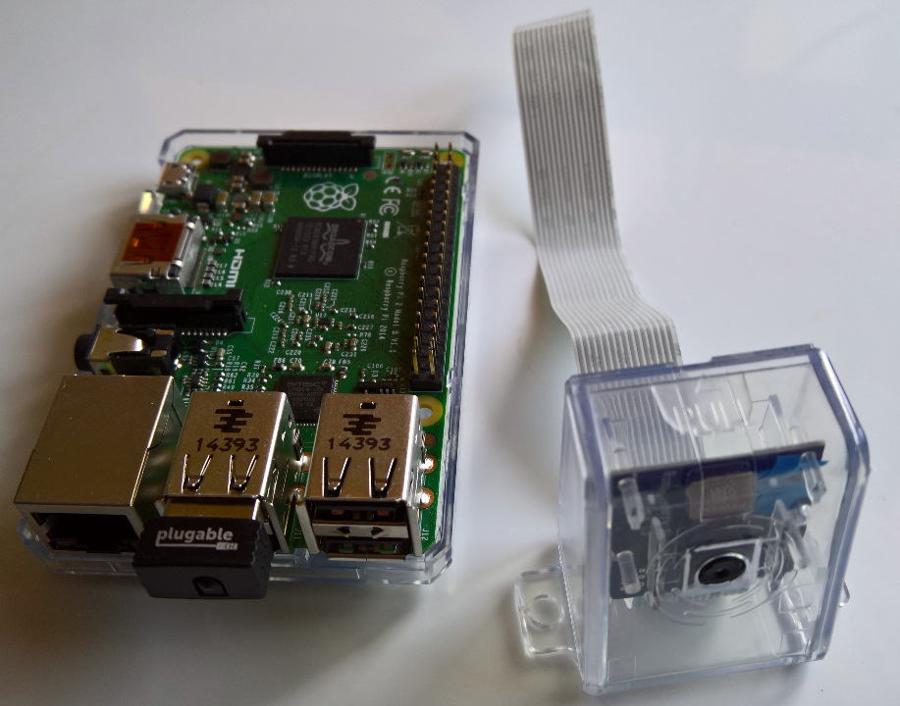

Figure 2: Device with Camera Module

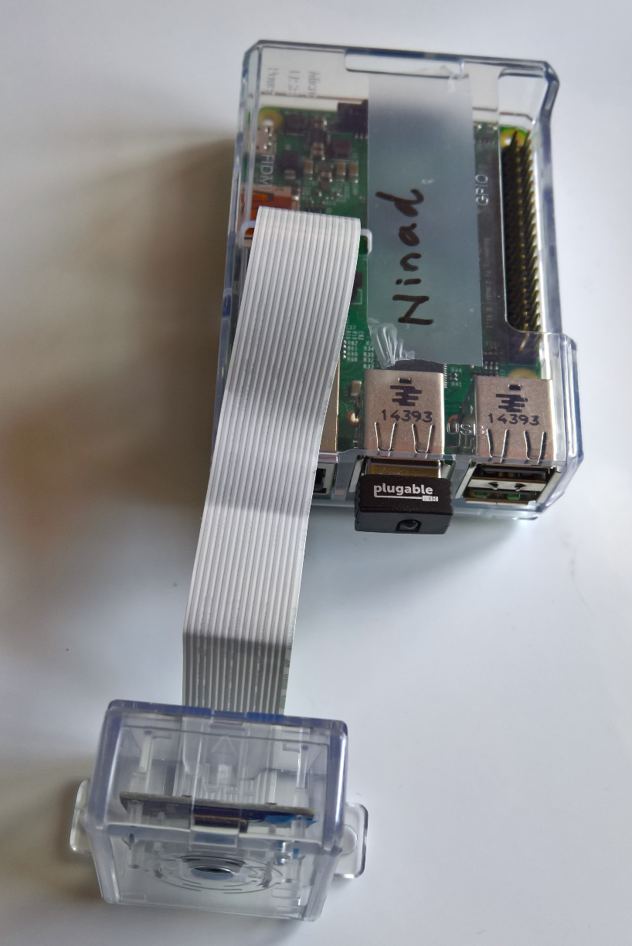

Figure 3: Raspberry Pi device with connected camera module

### Connecting camera module

Full documentation on how to connect the camera, configuration options to switch-on the camera operations and trouble-shooting can be found [here](https://www.raspberrypi.org/documentation/usage/camera/raspicam/raspistill.md)

In order for the camera to take pictures, we’ll use the ‘raspistill’ application. This is a command line application and more technical information on it can be found [here](https://www.raspberrypi.org/documentation/usage/camera/raspicam/raspistill.md).

# Solution

## Plan

It’s important that we are aware of pay-as-you-go nature of the cloud economics and utilise cloud resources for the minimum time possible. In order for us to achieve that, we would keep the device operational, taking pictures, only during the day-time, which means our Raspberry camera would be in operation between dawn and dusk. The device would take pictures through the Raspberry Pi camera module every minute, store it in a folder on the device. This will be done for the first 56 minutes of every hour. In the last four minutes of every hour, the captured photographs would be copied to Microsoft Azure storage.

At the end of day, we would start our compute instance under Azure. The job for this compute instance is to concatenate all the photographs and convert the day’s capture into a movie file. Pictorially, whole process can be depicted as following.

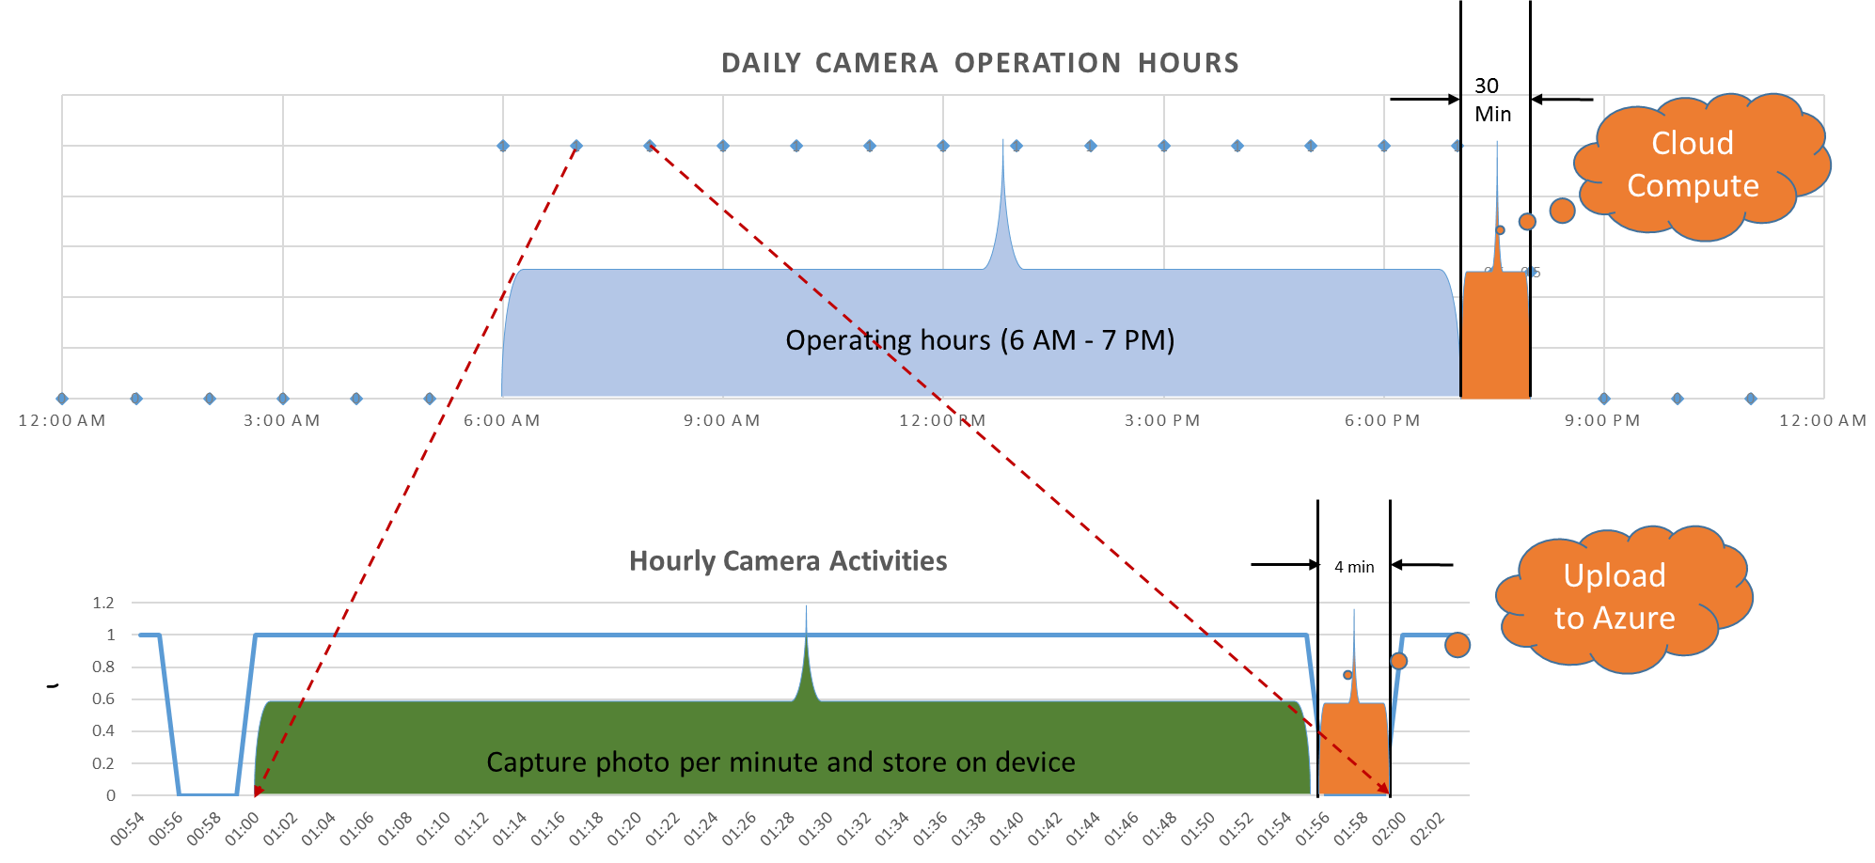

Script for capturing one photo

#!/bin/bash

DATE=$(date +"%Y-%m-%d_%H%M")

raspistill -o /home/pi/pictures/$DATE.jpg